1. Design NFA to accept any number of a’s where input={a,b}.

INPUT:

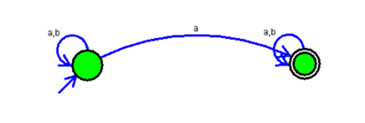

OUTPUT:

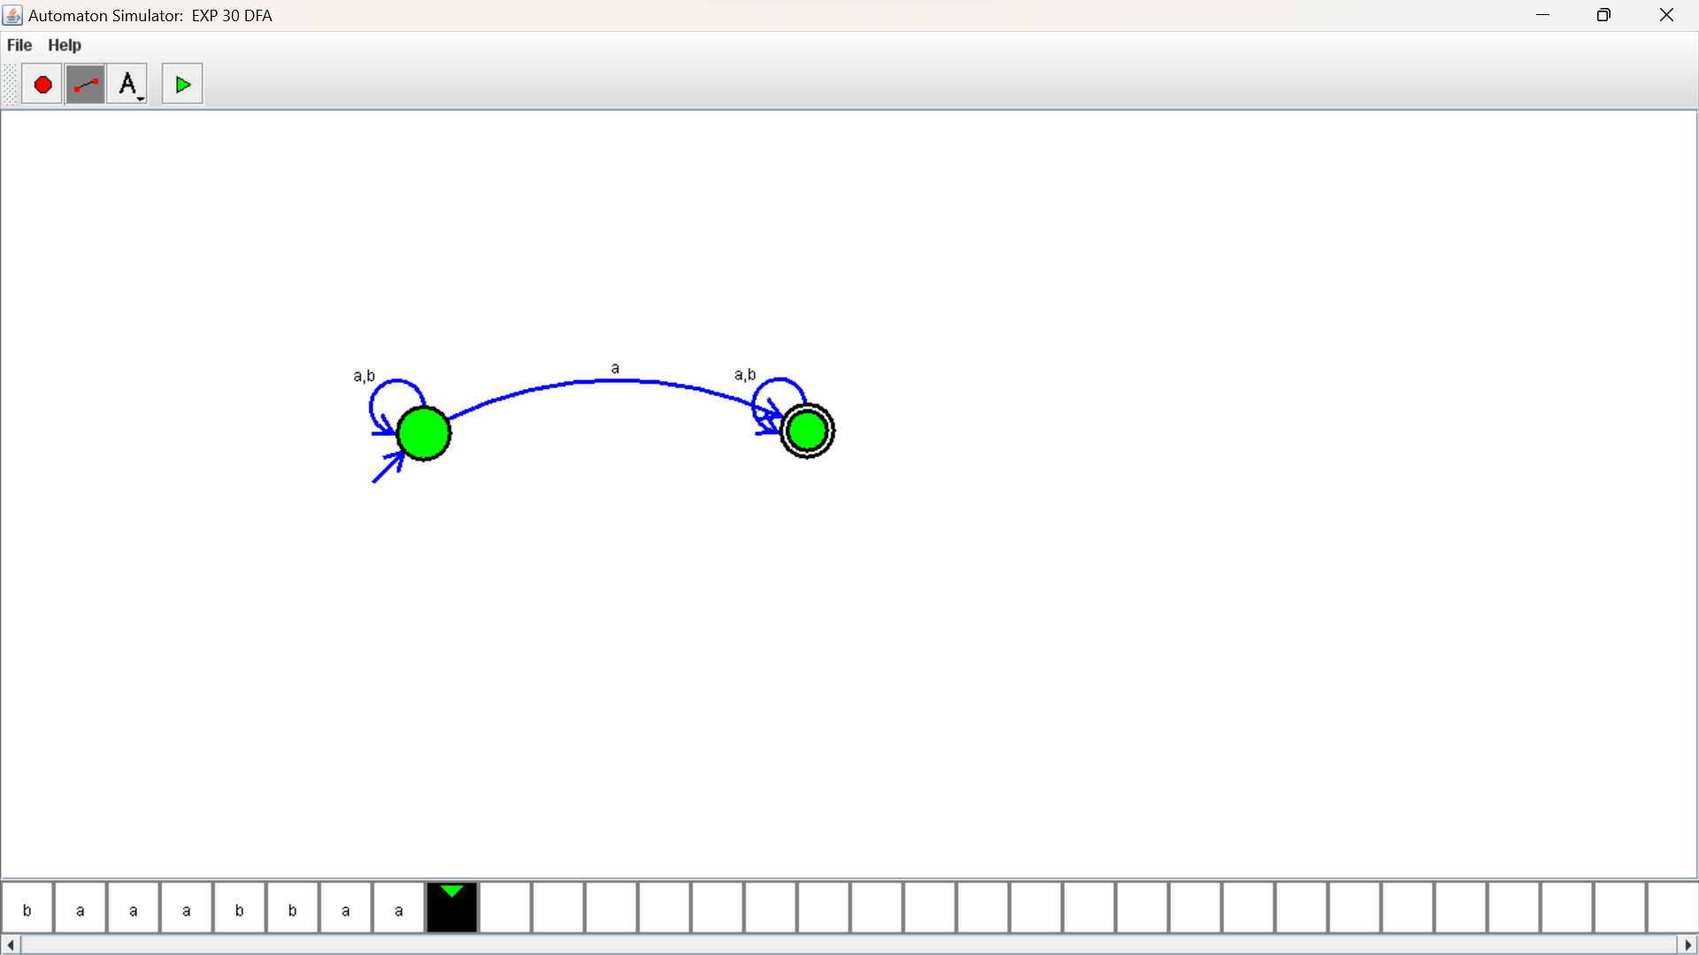

RESULTS:

NFA to accept any number of a’s where input={a,b}.by autosim stimulator